Copper Beech Inn and Restaurant l 46 Main St l Ivoryton,CT l 06442

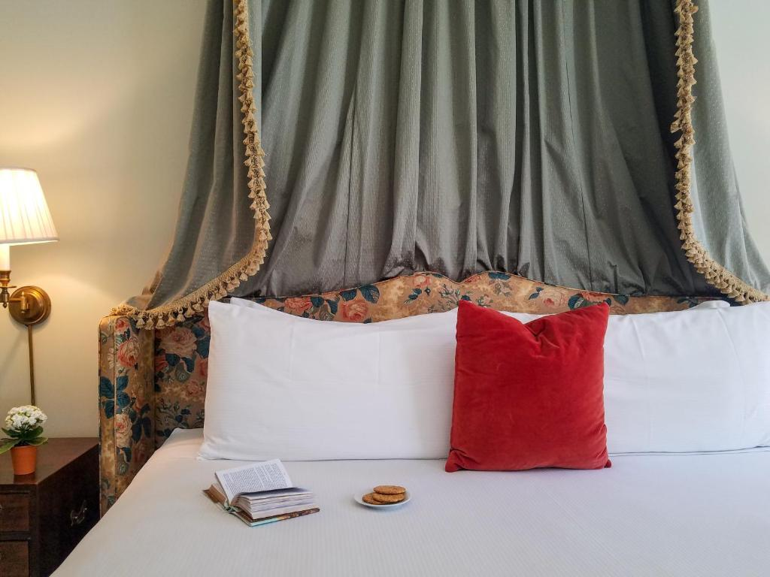
The Year in Numbers
Net Reservations: 1,886
RevPAR (Room Rev./20rooms): $146.00

Total Guest Rooms: 22
Number of Buildings: 3
Number of Employees: 23

- Copper Beech Inn (CBI) opened as Johnny Cake Lane Inn in the 1950’s after serving as a homestead to the Comstock Family for over 100 years.
- Mission: Copper Beech Inn does vacation right. Guests can’t go wrong with full breakfast every morning, a French American restaurant on-site, copper bar, and a new feature:in-room couples massage therapy. Our mission of unsurpassed, quality service shows in our constant ability to greet customers by name and put on grand events. We can’t wait to welcome you.
- Top attractions: the Goodspeed Opera House and Ivoryton Playhouse. CBI has had a long standing relationship with Ivoryton Playhouse with the goal of offering premier packages including dinner and a show, and more. Ivoryton Playhouse is a 1 minute drive. Goodspeed is only a 15 minute drive.
- The inn is named after the iconic copper beech tree that once stood for 120 years in front of the property. A new one has since been planted and is attended to on a daily basis.
- CBI has won many awards such as Best of Connecticut in 2011 and has been recognized as one of the top 100 restaurants in the United States by USA Today.

